Question 3

(a)

* **Average Excess Return**

|  |  |
| --- | --- |
| * Bond | * Excess Return |
| * SB Non-US Bonds | * 0.84% |
| * MSCI EAFE | * 1.03% |
| * CRSP VW US common stocks | * 0.85% |
| * US Corp Bonds | * 0.49% |
|  |  |

* **Standard Deviation**

|  |  |
| --- | --- |
| * Bond | * Standard Deviation |
| * SB Non-US Bonds | * 3.67% |
| * MSCI EAFE | * 5.87% |
| * CRSP VW US common stocks | * 4.73% |
| * US Corp Bonds | * 1.57% |
|  |  |

* **Correlation Matrix**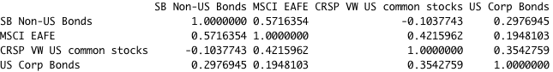

(b)

The weights calculated by the spreedsheet is shown below.

|  |  |
| --- | --- |
| Bond | Weight |
| SB Non-US Bonds | 27.38% |
| MSCI EAFE | -3.83% |
| CRSP VW US common stocks | 14.87% |
| US Corp Bonds | 61.58% |

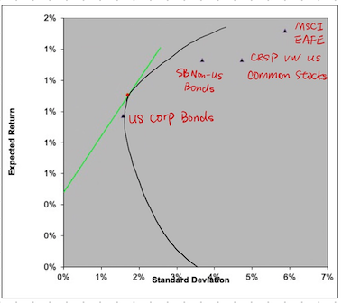

(c)

I prefer the portfolio at the tangent point rather than the the MVP since the investor can have the largest utility at the tangent portfolio though it is more risky than the MVP. Based on the therom of economics, people make decisions based how much utility they have and risk is less important so it would be better to select the tangent portfolio.